Coronavirus disease 2019 (COVID-19)
Situation Report – 62

Data as reported by national authorities by 23:59 CET 21 March 2020

HIGHLIGHTS
- Four new countries/territories/areas from the African Region have reported cases of COVID-19.

- As COVID-19 cases continue to increase, many countries are requesting individuals to stay at home in self-quarantine. WHO EURO has released a guide on how to stay physically active during self-quarantine. Information can be found here.

- There has been a rise in criminals disguising themselves as WHO to steal money or sensitive information. WHO urges individuals to stay alert and to verify the authenticity of the request. Information on protecting yourselves against scams as well as reporting the scam to WHO can be found here.
SITUATION IN NUMBERS
total (new) cases in last 24 hours

Globally
292 142 confirmed (26 069)
12 783 deaths (1600)
Western Pacific Region
94 787 confirmed (750)
3438 deaths (12)

European Region
151 293 confirmed (22 752)
7425 deaths (1426)

South-East Asia Region
1257 confirmed (278)
45 deaths (7)

Eastern Mediterranean Region
23 669 confirmed (1314)
1596 deaths (130)

Region of the Americas
19 685 confirmed (808)
252 deaths (17)

African Region
739 confirmed (167)
20 deaths (8)

WHO RISK ASSESSMENT
Global Level Very High

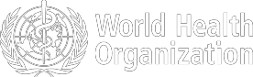

Figure 1. Countries, territories or areas with reported confirmed cases of COVID-19, 21 March 2020

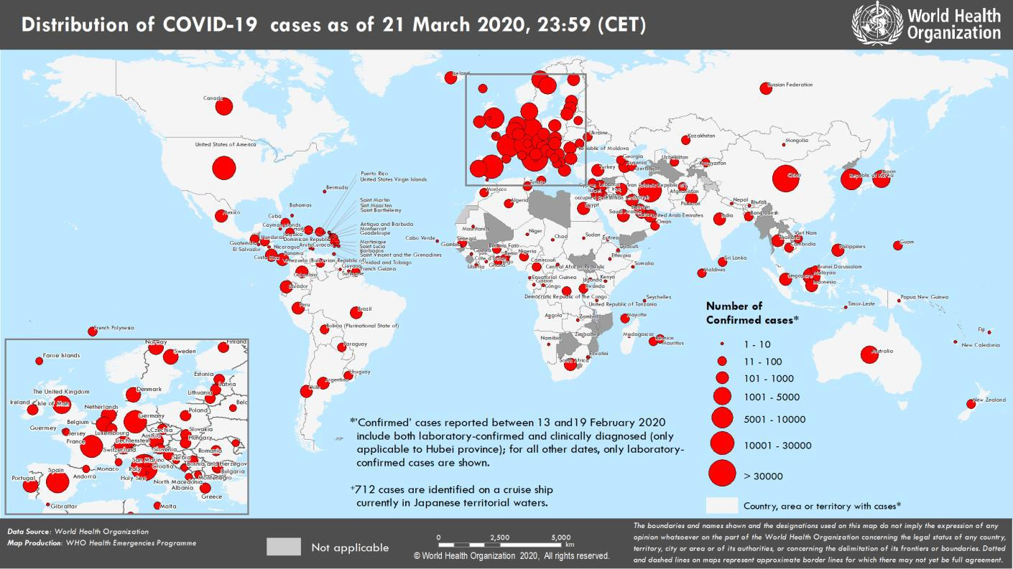

SURVEILLANCE

Table 1. Countries, territories or areas with reported laboratory-confirmed COVID-19 cases and deaths. Data as of 21 March 2020*
Reporting Country/ Territory/Area† | Total confirmed  ‡ cases | Total confirmed new cases | Total deaths | Total new deaths | Transmission classification§ | Days since last reported case
Western Pacific Region
China | 81498 | 82 | 3267 | 6 | Local transmission | 0
Republic of Korea | 8897 | 98 | 104 | 2 | Local transmission | 0
Malaysia | 1183 | 153 | 3 | 0 | Local transmission | 0
Australia | 1081 | 208 | 7 | 0 | Local transmission | 0
Japan | 1046 | 50 | 36 | 1 | Local transmission | 0
Singapore | 432 | 47 | 2 | 2 | Local transmission | 0
Philippines | 307 | 77 | 19 | 1 | Local transmission | 0
Viet Nam | 94 | 3 | 0 | 0 | Local transmission | 0
Brunei Darussalam | 83 | 5 | 0 | 0 | Local transmission | 0
New Zealand | 66 | 13 | 0 | 0 | Local transmission | 0
Cambodia | 53 | 2 | 0 | 0 | Local transmission | 0
Mongolia | 10 | 4 | 0 | 0 | Imported cases only | 0
Fiji | 2 | 1 | 0 | 0 | Local transmission | 0
Papua New Guinea | 1 | 0 | 0 | 0 | Imported cases only | 1
Territories**
French Polynesia | 15 | 4 | 0 | 0 | Imported cases only | 0
Guam | 15 | 1 | 0 | 0 | Local transmission | 0
New Caledonia | 4 | 2 | 0 | 0 | Imported cases only | 0
European Region ^
Italy | 53578 | 6557 | 4827 | 795 | Local transmission | 0
Spain | 24926 | 4946 | 1326 | 324 | Local transmission | 0
Germany | 21463 | 3140 | 67 | 22 | Local transmission | 0
France | 14296 | 1821 | 562 | 112 | Local transmission | 0
Switzerland | 6077 | 1237 | 56 | 13 | Local transmission | 0
The United Kingdom | 5018 | 1035 | 233 | 56 | Local transmission | 0
Netherlands | 3631 | 637 | 136 | 30 | Local transmission | 0
Austria | 3024 | 375 | 8 | 2 | Local transmission | 0
Belgium | 2815 | 558 | 67 | 30 | Local transmission | 0
Norway | 1926 | 184 | 7 | 0 | Local transmission | 0
Sweden | 1746 | 123 | 20 | 4 | Local transmission | 0
Denmark | 1326 | 71 | 13 | 4 | Local transmission | 0
Portugal | 1280 | 260 | 12 | 6 | Local transmission | 0
Czechia | 995 | 91 | 0 | 0 | Local transmission | 0
Turkey | 947 | 277 | 21 | 12 | Local transmission | 0
Israel | 883 | 171 | 1 | 0 | Local transmission | 0
Ireland | 785 | 102 | 3 | 0 | Local transmission | 0
Luxembourg | 670 | 186 | 8 | 3 | Local transmission | 0
Poland | 536 | 111 | 5 | 0 | Local transmission | 0
Greece | 530 | 35 | 13 | 5 | Local transmission | 0
Finland | 521 | 71 | 1 | 1 | Local transmission | 0
Iceland | 473 | 64 | 1 | 0 | Local transmission | 0
Slovenia | 383 | 42 | 1 | 0 | Local transmission | 0
Romania | 367 | 59 | 0 | 0 | Local transmission | 0
Estonia | 306 | 23 | 0 | 0 | Local transmission | 0
Russian Federation | 306 | 53 | 0 | 0 | Local transmission | 0
Croatia | 206 | 80 | 0 | 0 | Local transmission | 0

Slovakia | 178 | 41 | 0 | 0 | Local transmission | 0
Serbia†† | 173 | 38 | 1 | 0 | Local transmission | 0
Bulgaria | 163 | 36 | 3 | 0 | Local transmission | 0
Armenia | 160 | 24 | 0 | 0 | Local transmission | 0
San Marino | 151 | 0 | 20 | 6 | Local transmission | 1
Hungary | 131 | 46 | 4 | 0 | Local transmission | 0
Latvia | 124 | 13 | 0 | 0 | Imported cases only | 0
Lithuania | 105 | 36 | 1 | 0 | Imported cases only | 0
Bosnia and Herzegovina | 92 | 48 | 1 | 1 | Local transmission | 0
Andorra | 88 | 13 | 0 | 0 | Imported cases only | 0
North Macedonia | 85 | 15 | 0 | 0 | Local transmission | 0
Cyprus | 84 | 17 | 0 | 0 | Local transmission | 0
Republic of Moldova | 80 | 14 | 1 | 0 | Local transmission | 0
Albania | 76 | 6 | 2 | 0 | Local transmission | 0
Belarus | 76 | 19 | 0 | 0 | Local transmission | 0
Malta | 73 | 9 | 0 | 0 | Imported cases only | 0
Kazakhstan | 56 | 3 | 0 | 0 | Imported cases only | 0
Azerbaijan | 53 | 9 | 1 | 0 | Imported cases only | 0
Georgia | 49 | 6 | 0 | 0 | Imported cases only | 0
Ukraine | 47 | 21 | 3 | 0 | Local transmission | 0
Liechtenstein | 36 | 2 | 0 | 0 | Imported cases only | 0
Uzbekistan | 33 | 0 | 0 | 0 | Local transmission | 1
Monaco | 18 | 6 | 0 | 0 | Under investigation | 0
Kyrgyzstan | 14 | 8 | 0 | 0 | Imported cases only | 0
Montenegro | 14 | 0 | 0 | 0 | Imported cases only | 1
Holy See | 1 | 0 | 0 | 0 | Under investigation | 15
Territories**
Faroe Islands | 92 | 12 | 0 | 0 | Local transmission | 0
Jersey | 12 | 0 | 0 | 0 | Imported cases only | 1
Gibraltar | 10 | 0 | 0 | 0 | Under investigation | 2
Greenland | 2 | 0 | 0 | 0 | Under investigation | 3
Isle of Man | 2 | 1 | 0 | 0 | Imported cases only | 0
Guernsey | 1 | 0 | 0 | 0 | Imported cases only | 12
South-East Asia Region
Indonesia | 450 | 81 | 38 | 6 | Local transmission | 0
Thailand | 411 | 89 | 1 | 0 | Local transmission | 0
India | 283 | 88 | 4 | 0 | Local transmission | 0
Sri Lanka | 72 | 13 | 0 | 0 | Local transmission | 0
Bangladesh | 24 | 7 | 2 | 1 | Local transmission | 0
Maldives | 13 | 0 | 0 | 0 | Local transmission | 6
Bhutan | 2 | 0 | 0 | 0 | Imported cases only | 2
Nepal | 1 | 0 | 0 | 0 | Imported cases only | 58
Timor-Leste | 1 | 0 | 0 | 0 | Imported cases only | 1
Eastern Mediterranean Region
Iran (Islamic Republic of) | 20610 | 966 | 1556 | 123 | Local transmission | 0
Pakistan | 495 | 34 | 3 | 1 | Local transmission | 0
Qatar | 470 | 10 | 0 | 0 | Local transmission | 0
Saudi Arabia | 392 | 118 | 0 | 0 | Local transmission | 0
Bahrain | 306 | 21 | 1 | 0 | Local transmission | 0
Egypt | 285 | 29 | 8 | 1 | Local transmission | 0
Iraq | 214 | 21 | 17 | 3 | Local transmission | 0
Lebanon | 206 | 43 | 4 | 0 | Local transmission | 0

Kuwait | 176 | 17 | 0 | 0 | Local transmission | 0
United Arab Emirates | 153 | 13 | 2 | 2 | Local transmission | 0
Morocco | 86 | 12 | 3 | 0 | Local transmission | 0
Jordan | 84 | 15 | 0 | 0 | Imported cases only | 0
Tunisia | 60 | 6 | 1 | 0 | Local transmission | 0
Oman | 52 | 4 | 0 | 0 | Local transmission | 0
Afghanistan | 24 | 0 | 0 | 0 | Imported cases only | 1
Sudan | 2 | 1 | 1 | 0 | Imported cases only | 0
Djibouti | 1 | 0 | 0 | 0 | Under investigation | 3
Somalia | 1 | 0 | 0 | 0 | Imported cases only | 5
Territories**
occupied Palestinian territory | 52 | 4 | 0 | 0 | Local transmission | 0
Region of the Americas
United States of America | 15219 | 0 | 201 | 0 | Local transmission | 1
Canada | 1048 | 202 | 13 | 4 | Local transmission | 0
Brazil | 904 | 283 | 11 | 7 | Local transmission | 0
Ecuador | 506 | 139 | 7 | 2 | Local transmission | 0
Chile | 434 | 0 | 1 | 1 | Local transmission | 1
Peru | 318 | 84 | 2 | 0 | Local transmission | 0
Colombia | 196 | 51 | 0 | 0 | Local transmission | 0
Mexico | 164 | 0 | 1 | 0 | Imported cases only | 1
Argentina | 158 | 30 | 3 | 0 | Local transmission | 0
Panama | 137 | 0 | 1 | 0 | Local transmission | 1
Costa Rica | 113 | 0 | 2 | 0 | Local transmission | 1
Uruguay | 94 | 0 | 0 | 0 | Imported cases only | 1
Dominican Republic | 72 | 0 | 2 | 0 | Local transmission | 1
Venezuela (Bolivarian Republic of) | 36 | 0 | 0 | 0 | Imported cases only | 3
Honduras | 24 | 0 | 0 | 0 | Imported cases only | 1
Bolivia (Plurinational State of) | 19 | 3 | 0 | 0 | Local transmission | 0
Paraguay | 18 | 5 | 1 | 1 | Local transmission | 0
Cuba | 16 | 0 | 1 | 0 | Imported cases only | 1
Jamaica | 16 | 0 | 1 | 0 | Local transmission | 1
Guatemala | 12 | 0 | 1 | 0 | Imported cases only | 1
Trinidad and Tobago | 9 | 0 | 0 | 0 | Imported cases only | 2
Barbados | 5 | 0 | 0 | 0 | Imported cases only | 1
Guyana | 5 | 0 | 1 | 0 | Local transmission | 3
Bahamas | 4 | 0 | 0 | 0 | Local transmission | 1
Haiti | 2 | 0 | 0 | 0 | Imported cases only | 1
Nicaragua | 2 | 1 | 0 | 0 | Imported cases only | 0
Saint Lucia | 2 | 0 | 0 | 0 | Imported cases only | 6
Suriname | 2 | 0 | 0 | 0 | Imported cases only | 1
Antigua and Barbuda | 1 | 0 | 0 | 0 | Imported cases only | 8
El Salvador | 1 | 0 | 0 | 0 | Imported cases only | 2
Saint Vincent and the Grenadines | 1 | 0 | 0 | 0 | Imported cases only | 8
Territories**
Guadeloupe | 51 | 0 | 0 | 0 | Imported cases only | 1
Martinique | 32 | 0 | 0 | 0 | Imported cases only | 2
Puerto Rico | 21 | 7 | 1 | 1 | Imported cases only | 0
French Guiana | 15 | 0 | 0 | 0 | Local transmission | 2

United States Virgin Islands | 6 | 3 | 0 | 0 | Imported cases only | 0
Aruba | 5 | 0 | 0 | 0 | Imported cases only | 2
Saint Martin | 4 | 0 | 0 | 0 | Under investigation | 3
Cayman Islands | 3 | 0 | 1 | 0 | Imported cases only | 2
Curaçao | 3 | 0 | 1 | 1 | Imported cases only | 4
Saint Barthélemy | 3 | 0 | 0 | 0 | Under investigation | 6
Bermuda | 2 | 0 | 0 | 0 | Imported cases only | 3
Montserrat | 1 | 0 | 0 | 0 | Imported cases only | 3
Sint Maarten | 1 | 0 | 0 | 0 | Imported cases only | 3
African Region
South Africa | 240 | 35 | 0 | 0 | Local transmission | 0
Algeria | 94 | 0 | 15 | 5 | Local transmission | 1
Burkina Faso | 72 | 32 | 3 | 2 | Local transmission | 0
Senegal | 56 | 18 | 0 | 0 | Local transmission | 0
Cameroon | 27 | 5 | 0 | 0 | Local transmission | 0
Democratic Republic of the Congo | 23 | 9 | 1 | 1 | Local transmission | 0
Nigeria | 22 | 10 | 0 | 0 | Imported cases only | 0
Ghana | 19 | 3 | 0 | 0 | Local transmission | 0
Rwanda | 17 | 6 | 0 | 0 | Local transmission | 0
Togo | 15 | 6 | 0 | 0 | Imported cases only | 0
Mauritius | 12 | 0 | 0 | 0 | Imported cases only | 1
Côte d’Ivoire | 9 | 0 | 0 | 0 | Imported cases only | 3
Ethiopia | 9 | 0 | 0 | 0 | Imported cases only | 2
Kenya | 7 | 0 | 0 | 0 | Local transmission | 3
Seychelles | 7 | 1 | 0 | 0 | Imported cases only | 0
Equatorial Guinea | 6 | 2 | 0 | 0 | Imported cases only | 0
United Republic of Tanzania | 6 | 0 | 0 | 0 | Imported cases only | 2
Congo | 4 | 1 | 0 | 0 | Imported cases only | 0
Cabo Verde | 3 | 2 | 0 | 0 | Imported cases only | 0
Central African Republic | 3 | 2 | 0 | 0 | Imported cases only | 0
Gabon | 3 | 0 | 1 | 0 | Imported cases only | 3
Liberia | 3 | 1 | 0 | 0 | Local transmission | 0
Madagascar | 3 | 3 | 0 | 0 | Under investigation | 0
Namibia | 3 | 0 | 0 | 0 | Imported cases only | 2
Angola | 2 | 2 | 0 | 0 | Imported cases only | 0
Benin | 2 | 0 | 0 | 0 | Imported cases only | 2
Guinea | 2 | 0 | 0 | 0 | Imported cases only | 2
Mauritania | 2 | 0 | 0 | 0 | Imported cases only | 3
Zambia | 2 | 0 | 0 | 0 | Imported cases only | 3
Zimbabwe | 2 | 1 | 0 | 0 | Imported cases only | 0
Chad | 1 | 0 | 0 | 0 | Imported cases only | 2
Eritrea | 1 | 1 | 0 | 0 | Imported cases only | 0
Eswatini | 1 | 0 | 0 | 0 | Imported cases only | 7
Gambia | 1 | 0 | 0 | 0 | Imported cases only | 3
Niger | 1 | 0 | 0 | 0 | Imported cases only | 2
Uganda | 1 | 1 | 0 | 0 | Imported cases only | 0
Territories**
Réunion | 47 | 19 | 0 | 0 | Imported cases only | 0
Mayotte | 11 | 7 | 0 | 0 | Imported cases only | 0
Subtotal for all | 291430 | 26069 | 12776 | 1600

regions
International conveyance (Diamond Princess) | 712 | 0 | 7 | 0 | Local transmission | 6
Grand total | 292142 | 26069 | 12783 | 1600
*Numbers include both domestic and repatriated cases
†The designations employed and the presentation of the material in this publication do not imply the expression of any opinion whatsoever on the part of WHO concerning the legal status of any country, territory, city or area or of its authorities, or concerning the delimitation of its frontiers or boundaries. Dotted and dashed lines on maps represent approximate border lines for which there may not yet be full agreement.
‡Case classifications are based on WHO case definitions for COVID-19.
§Transmission classification is based on WHO analysis of available official data and may be subject to reclassification as additional data become available. Countries/territories/areas experiencing multiple types of transmission are classified in the highest category for which there is evidence; they may be removed from a given category if interruption of transmission can be demonstrated. It should be noted that even within categories, different countries/territories/areas may have differing degrees of transmission as indicated by the differing numbers of cases and other factors. Not all locations within a given country/territory/area are equally affected.
Terms:
- Community transmission is evidenced by the inability to relate confirmed cases through chains of transmission for a large number of cases, or by increasing positive tests through sentinel samples (routine systematic testing of respiratory samples from established laboratories).
- Local transmission indicates locations where the source of infection is within the reporting location.
- Imported cases only indicates locations where all cases have been acquired outside the location of reporting.
- Under investigation indicates locations where type of transmission has not been determined for any cases.
- Interrupted transmission indicates locations where interruption of transmission has been demonstrated (details to be determined)
** “Territories” include territories, areas, overseas dependencies and other jurisdictions of similar status
^ Data for the European Region is obtained from the European Centre for Disease Control and Prevention (ECDC)
††Including 24 (0 new) cases from Kosovo[1]
[1] All references to Kosovo should be understood to be in the context of the United Nations Security Council resolution 1244 (1999).

Due to differences in reporting methods, retrospective data consolidation, and reporting delays, the number of new cases may not always reflect the exact difference between yesterday’s and today’s totals. WHO COVID-19 Situation Reports present official counts of confirmed COVID-19 cases, thus differences between WHO reports and other sources of COVID-19 data using different inclusion criteria and different data cutoff times are to be expected.

New countries/territories/areas are shown in red. Erratum: Total deaths have been revised for Croatia.
Figure 2. Epidemic curve of confirmed COVID-19, by date of report and WHO region through 21 March 2020

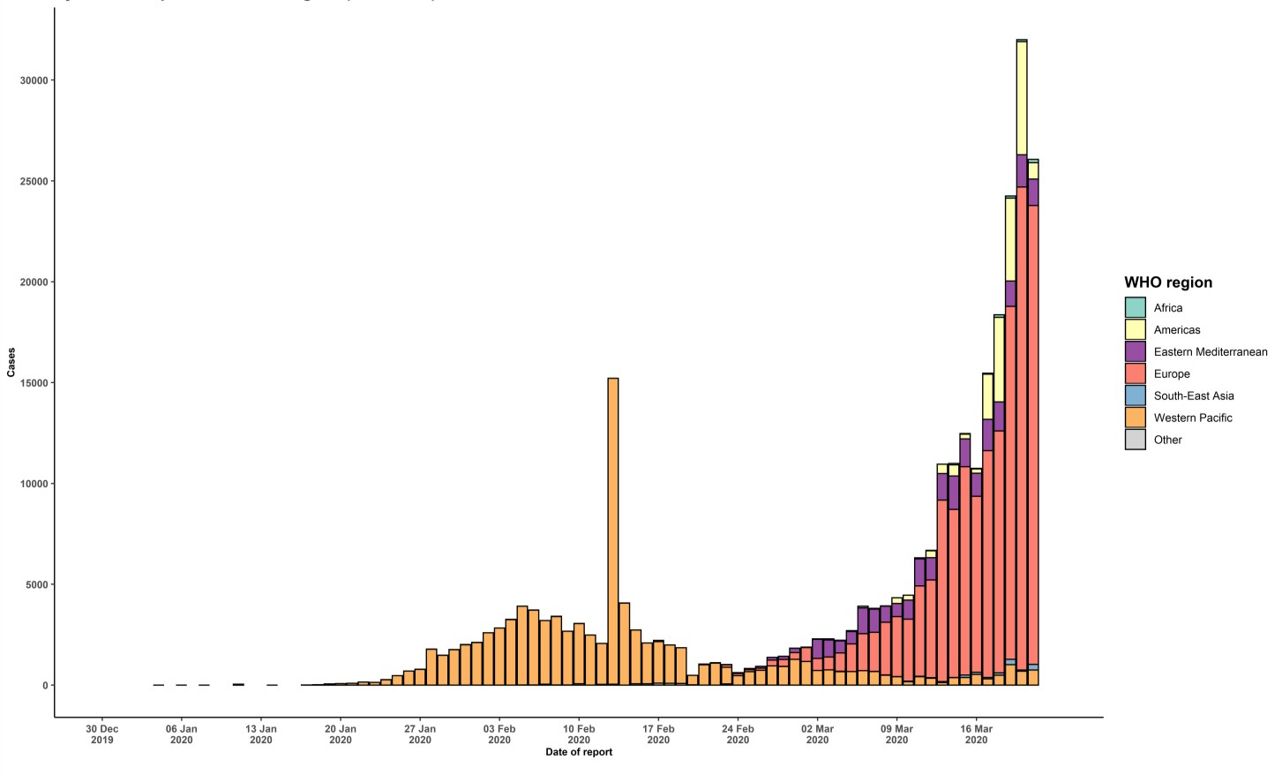
Note that the apparent decrease in number of cases may be due to a reporting bias during the weekend.

STRATEGIC OBJECTIVES

WHO’s strategic objectives for this response are to:

  - Interrupt human-to-human transmission including reducing secondary infections among close contacts and health care workers, preventing transmission amplification events, and preventing further international spread*;
  - Identify, isolate and care for patients early, including providing optimized care for infected patients;
  - Identify and reduce transmission from the animal source;
  - Address crucial unknowns regarding clinical severity, extent of transmission and infection, treatment options, and accelerate the development of diagnostics, therapeutics and vaccines;
  - Communicate critical risk and event information to all communities and counter misinformation;
  - Minimize social and economic impact through multisectoral partnerships.

*This can be achieved through a combination of public health measures, such as rapid identification, diagnosis and management of the cases, identification and follow up of the contacts, infection prevention and control in health care settings, implementation of health measures for travelers, awareness-raising in the population and risk communication.
PREPAREDNESS AND RESPONSE
- To view all technical guidance documents regarding COVID-19, please go to this webpage.
- WHO has developed interim guidance for laboratory diagnosis, advice on the use of masks during home care and in health care settings in the context of the novel coronavirus (2019-nCoV) outbreak, clinical management, infection prevention and control in health care settings, home care for patients with suspected novel coronavirus, risk communication and community engagement and Global Surveillance for human infection with novel coronavirus (2019-nCoV).
- WHO is working closely with International Air Transport Association (IATA) and have jointly developed a guidance document to provide advice to cabin crew and airport workers, based on country queries. The guidance can be found on the IATA webpage.
- WHO has been in regular and direct contact with Member States where cases have been reported. WHO is also informing other countries about the situation and providing support as requested.
- WHO is working with its networks of researchers and other experts to coordinate global work on surveillance, epidemiology, mathematical modelling, diagnostics and virology, clinical care and treatment, infection prevention and control, and risk communication. WHO has issued interim guidance for countries, which are updated regularly.
- WHO has prepared a disease commodity package that includes an essential list of biomedical equipment, medicines and supplies necessary to care for patients with 2019-nCoV.
- WHO has provided recommendations to reduce risk of transmission from animals to humans.
- WHO has published an updated advice for international traffic in relation to the outbreak of the novel coronavirus 2019-nCoV.
- WHO has activated the R&D blueprint to accelerate diagnostics, vaccines, and therapeutics.
- OpenWHO is an interactive, web-based, knowledge-transfer platform offering online courses to improve the response to health emergencies. COVID-19 courses can be found here. Specifically, WHO has developed online courses on the following topics: A general introduction to emerging respiratory viruses, including novel coronaviruses (available in Arabic, Chinese, English, French, Russian, Spanish, Hindi, Persian, Portuguese, Serbian, and Turkish); Clinical Care for Severe Acute Respiratory Infections (available in English, French, Russian, and Vietnamese); Health and safety briefing for respiratory diseases - ePROTECT (available in English, French, Russian, Indonesian, and Portuguese); Infection Prevention and Control for Novel Coronavirus (COVID-19) (available in Chinese, English, French, Russian, Spanish, Indonesian, Italian, Japanese, Portuguese, and Serbian); and COVID-19 Operational Planning Guidelines and COVID-19 Partners Platform to support country preparedness and response (available in English and coming soon in additional languages).
- WHO is providing guidance on early investigations, which are critical in an outbreak of a new virus. The data collected from the protocols can be used to refine recommendations for surveillance and case definitions, to characterize the key epidemiological transmission features of COVID-19, help understand spread, severity, spectrum of disease, impact on the community and to inform operational models for implementation of countermeasures such as case isolation, contact tracing and isolation. Several protocols are available here. One such protocol is for the investigation of early COVID-19 cases and contacts (the “First Few X (FFX) Cases and contact investigation protocol for 2019-novel coronavirus (2019-nCoV) infection”). The protocol is designed to gain an early understanding of the key clinical, epidemiological and virological characteristics of the first cases of COVID-19 infection detected in any individual country, to inform the development and updating of public health guidance to manage cases and reduce the potential spread and impact of infection.
RECOMMENDATIONS AND ADVICE FOR THE PUBLIC

If you are not in an area where COVID-19 is spreading or have not travelled from an area where COVID-19 is spreading or have not been in contact with an infected patient, your risk of infection is low. It is understandable that you may feel anxious about the outbreak. Get the facts from reliable sources to help you accurately determine your risks so that you can take reasonable precautions (see Frequently Asked Questions). Seek guidance from WHO, your healthcare provider, your national public health authority or your employer for accurate information on COVID-19 and whether COVID-19 is circulating where you live. It is important to be informed of the situation and take appropriate measures to protect yourself and your family (see Protection measures for everyone).

If you are in an area where there are cases of COVID-19 you need to take the risk of infection seriously. Follow the advice of WHO and guidance issued by national and local health authorities. For most people, COVID-19 infection will cause mild illness however, it can make some people very ill and, in some people, it can be fatal. Older people, and those with pre-existing medical conditions (such as cardiovascular disease, chronic respiratory disease or diabetes) are at risk for severe disease (See Protection measures for persons who are in or have recently visited (past 14 days) areas where COVID-19 is spreading).

CASE DEFINITIONS

WHO periodically updates the Global Surveillance for human infection with coronavirus disease (COVID-19) document which includes case definitions.

For easy reference, case definitions are included below.

Suspect case
- A patient with acute respiratory illness (fever and at least one sign/symptom of respiratory disease, e.g., cough, shortness of breath), AND a history of travel to or residence in a location reporting community transmission of COVID-19 disease during the 14 days prior to symptom onset.
OR
- A patient with any acute respiratory illness AND having been in contact with a confirmed or probable COVID-19 case (see definition of contact) in the last 14 days prior to symptom onset;
OR
- A patient with severe acute respiratory illness (fever and at least one sign/symptom of respiratory disease, e.g., cough, shortness of breath; AND requiring hospitalization) AND in the absence of an alternative diagnosis that fully explains the clinical presentation.

Probable case
- A suspect case for whom testing for the COVID-19 virus is inconclusive.
  - Inconclusive being the result of the test reported by the laboratory.
OR
- A suspect case for whom testing could not be performed for any reason.

Confirmed case
A person with laboratory confirmation of COVID-19 infection, irrespective of clinical signs and symptoms.
- Technical guidance for laboratory testing can be found here.

Definition of contact
A contact is a person who experienced any one of the following exposures during the 2 days before and the 14 days
after the onset of symptoms of a probable or confirmed case:
- Face-to-face contact with a probable or confirmed case within 1 meter and for more than 15 minutes;
- Direct physical contact with a probable or confirmed case;
- Direct care for a patient with probable or confirmed COVID-19 disease without using proper personal protective equipment1; OR
- Other situations as indicated by local risk assessments.

Note: for confirmed asymptomatic cases, the period of contact is measured as the 2 days before through the 14 days
after the date on which the sample was taken which led to confirmation.

1 World Health Organization. Infection prevention and control during health care when COVID-19 is suspected https://www.who.int/publications-detail/infection-prevention-and-control-during-health-care-when-novel-coronavirus-(ncov)- infection-is-suspected-20200125

